Scrumptious Personal Financial Website
Software Design Document

Scrumptious
Scrumptious Personal financial Website

1st April 2018
Version 1.1

______________________________
[Project Lead Signature Block]

______________________________
[Project Manager Signature Block]

TABLE CONTENTS
1 Introduction 3
1.1 Purpose 3
1.2 Scope 3
2 Design Overview 4
2.1 Background Information 4
2.2 Alternatives 4
3 User Characteristics 5
4 Requirements and Constraints 5
4.1 Performance Requirements 5
4.2 Security Requirements 5
4.3 Design Constraints 6
5 System Architecture 6
6 Detailed Design 7
7 Data Architecture 8
7.1 Logical Database Model 8
7.2 Data Conversion 9
8 Interface Requirements 10
8.1 Required Interfaces 10
9 User Interface 10
9.1 Interface Design 11
10 Non-Functional Requirements 17
10.1 Performance Requirements 17
10.2 Security Requirements 17
10.3 Software Quality Attributes 17

Revision History
Name | Date | Reason For Changes | Version
D.K. | 9th February | New version developed | ALPHA
D.K. | 9th March | New Design Features added | BETA
D.K | 20th March | New Design Features added | Version 1.0
D.K | 1st April | New features added and code refactored | Version 1.1

Introduction

This document will serve as the official design documentation for the Scrumptious financial application website. The overarching goal of the project is to create a website that helps users effectively manage their finances.

Purpose
This Software design document is intended to describe the overall design of the website primarily to a developer who would like to understand how the website was designed. However this document will also be applicable for a general user simply interested in the design of the website as the technical language used is minimal.

Scope
The software products in reference within this document is the Scrumptious financial website.
The product will enable users to view and track their finances and also send and receive money from other website users.

This software will interface with user’s personal comupters, tablets or phones. It must therefore be quite versatile to be used on a varety of devices and web browsers.
This Document may evolve quite substantially during this development cycle as with each new iteration of the website new features may be added/ removed and therefore the final version may have some fairly significant differences from this initial version.
The goals of this project are:
- To provide a simple and straightforward website to be used by people aged 16-30 with little or no financial/technical knowledge.
- To provide a platform where users can clearly view their finances and manage their use of money
- To provide a platform that enables users to send and receive money form other users.
The product is built using HTML, Javascript and CSS from the front end and uses SQL in the back end to manage the database of user accounts and user details.

Design Overview

Background Information
The main stakeholders in regard to this website are the ‘Scrumptious Ltd’ company who provided the concpept and motivation for this project and the users who will ultimately receive the service.
With regard to this the company and several potential users of the product have been involved in the development process and have given in input which has bene incorporated into the overall system design.
Some project risks and their possible mitigations are as follows:

Time constraint- The time line for this project is quite short so there is the risk of running out of time before being able to complete the project. To mitigate this the project is being produced through a series of iterations which have been scheduled to continue until there is no more time left so there will always be a workable version of the product on site and ready to be viewed/ produced.

Cost constraints- This is a small constraint though it could affect the project as we do require a web hosting service which has an associated cost. To complete this we looked at various prices of web hosting and group members contributed their personal funds for the web hosting service. This was sufficient for web hosting.

Technical constraings- There is a constraing of technical expertise however as students we took our own initiateive to do the best we can and independently learn how to implement extra features.

The system will model the overall process fo a user managing their finanances by giving them an overview of where and how they spent their income and assisting them to therefore set financial targets. The website will also give iformation on possible inverstment avenues that the user can pursue.

Alternatives
The project was initially began as a mobile application though after consultation with the client this was changed to begin with a website. A major reason for this was to provide more flexibility as the users of the software may want to use it from a variety of devices and not simply a mobile phone.

User Characteristics
The 2 main users that shall use this product will be composed of include: general users and administrators.

The ‘General Users’ class is quite general and refers to anyone who uses the website for the general management of their personal finances. This will be people between 16-30 who are either just learning how to manage their finances or have some experience managing their finances.They should be able to view their account balances and transactions; send money from one account to another and have contact information to their financial services account.
To meet the requirements of these users the website will need to be easy and simple to use and will need to be able to work simply on a variety of devices.

The ‘Administrators’ will have the ability to manage user accounts by modifying the site and approving significant changes e.g. closing the account or closing an account with a financial institution. They shall also be in charge of maintaining the site and providing information on current products/services being offered and offer users financial assistance through the website platform.

Requirements and Constraints

Performance Requirements
The major performance requirement for this application is for it to ensure secure storage of each user’s information and provide the ability for the users to securely send money through the platform to another financial institution.

The Website shall also need to ensure that the user’s transaction data is updated and current by regularly refreshing data on the current account balances and transactions and prompting the user to upload .csv bank statements.

Security Requirements
Security is a very important aspect of this application and must therefore be treated as such. The two main aspects of this will be: user identification and secure storage of user data.
Regarding user identification, currently the website uses a password to protect user data though later revisions will look towards implementing two factor authentication using either a one-time access code or biometric authentication. This security feature will therefore ensure that the user’s identity is verified before they can access any information.
In terms of Data storage, all data will be encrypted and stored on the server for maximum security.

Design Constraints
Some design constraints include variability in the browser used/device used to view the product. To address this the design will use a ‘graceful degredation’ approach to ensure that it is usable on a variety of devices. During the design process a variety of devices will be used to test the website however this will be limited to the devices currently on had due to budget constraints.
Time will be another constraint on the design of this website. As the project duration is limited to 1 month the time we have for designing is limited. We shall therefore focus on the core design components before branching off to the smaller design attributes.

System Architecture
The overall system architecture design is provided diagrammatically below through the use of sequence diagrams. These illustrate the processes that users go through when navigating and using the websits and this provide an overview of the website design at a high level.

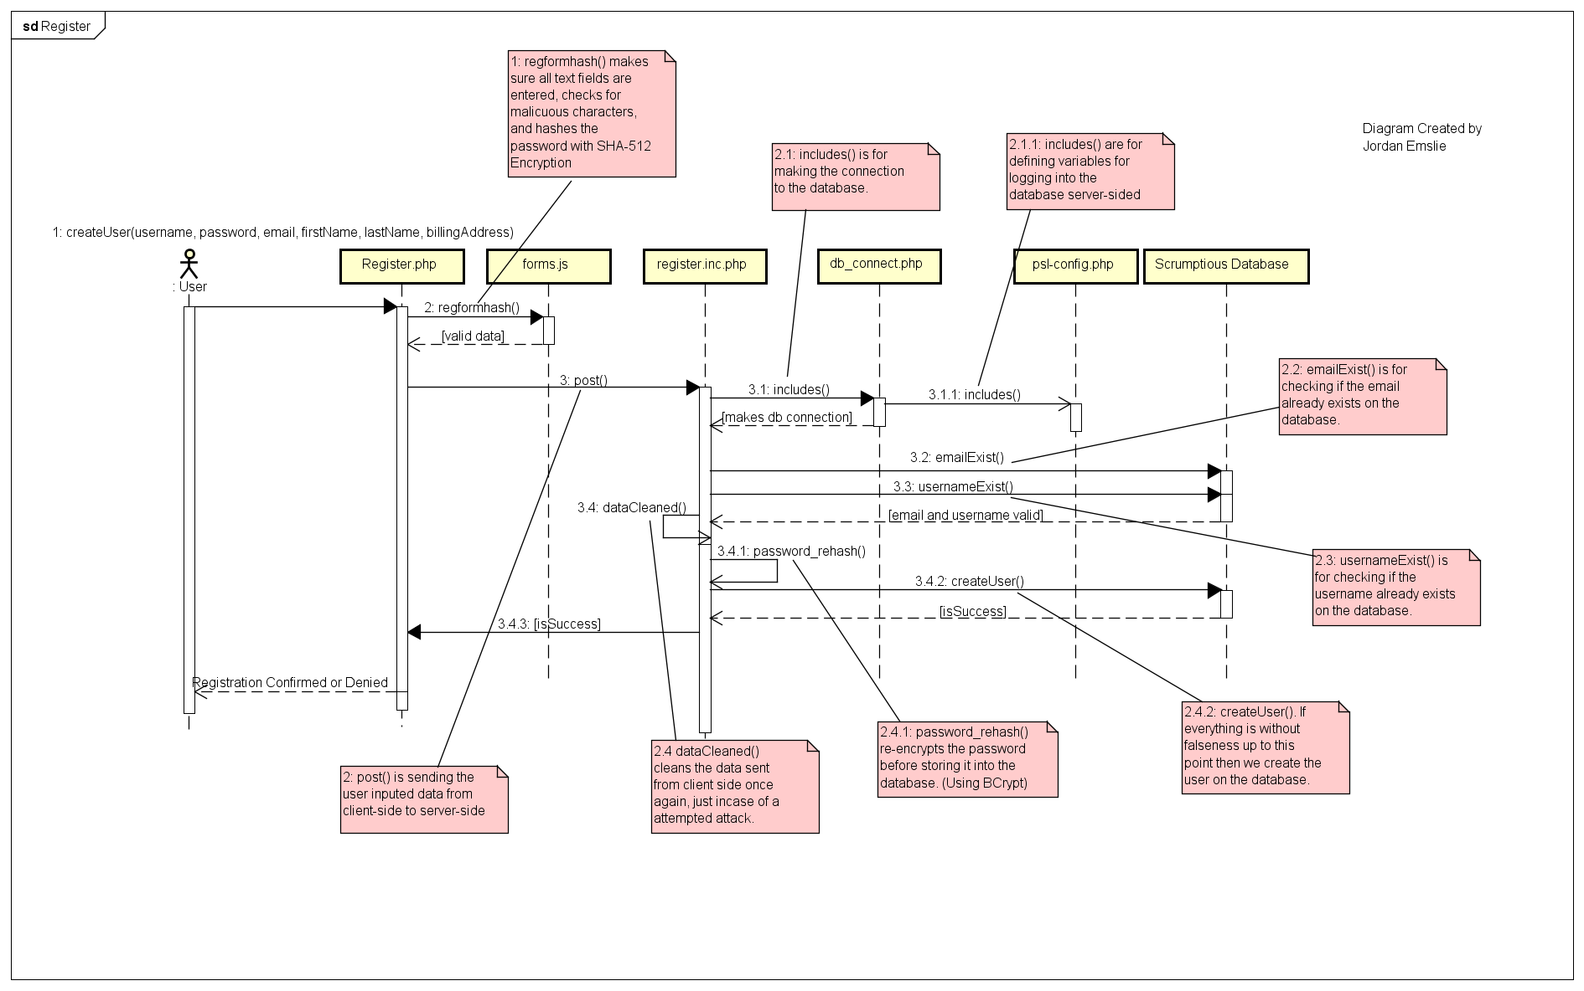
Register User Sequence diagram
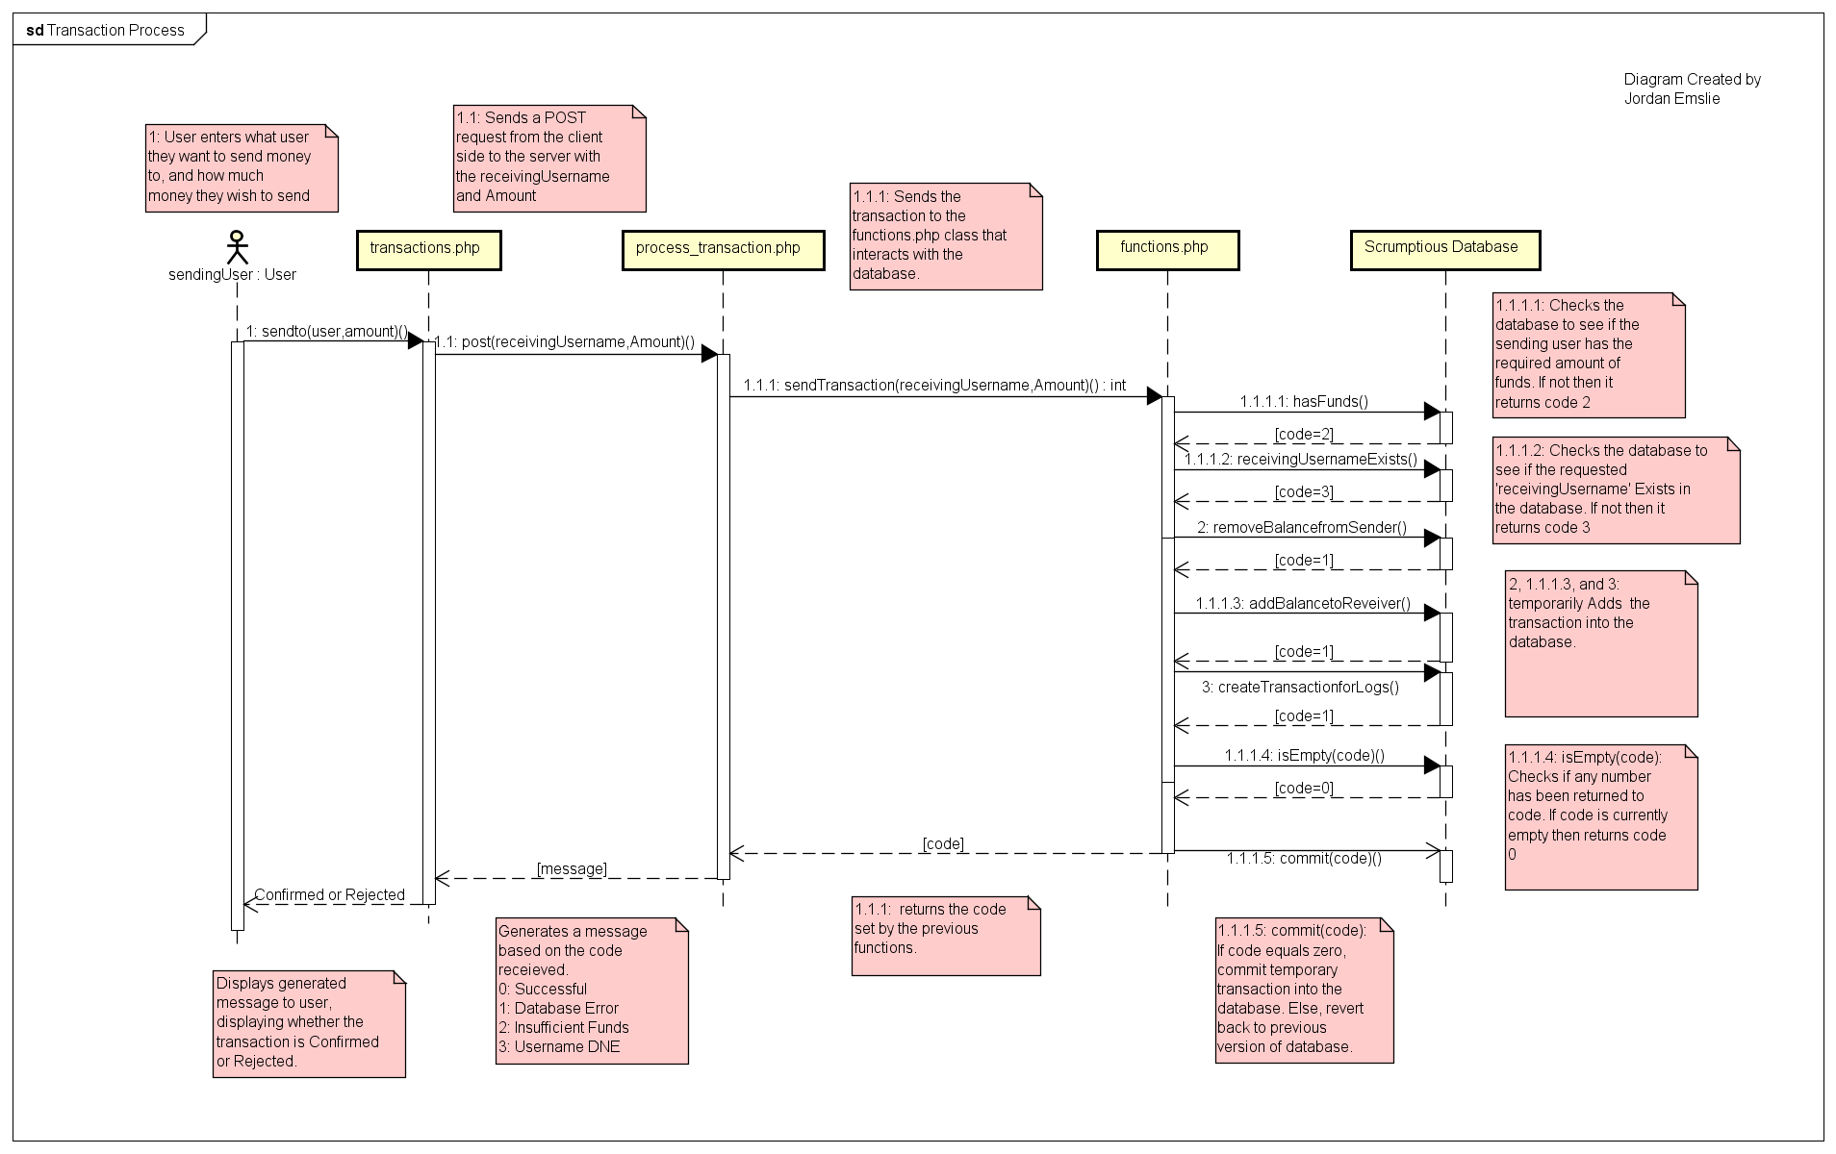
Transaction process sequence diagram

Detailed Design
The main components of this design are HTML, php and CSS pages which interact and enable the website to fully function. The php pages will have embedded SQL code which will be used to query and update the SQL database for user information.
The website is made up of several interlinked pages as explained below:

- The overview/ homepage which gives updates on financial news and if logged in the user will receive reminders on this page and view their overall expenditure in a pie chart.
To access any other page apart from this, the user shall need to log-in
- The ‘Register’ page which should allow the user to create a new account on the scrumptious website. The data to be entered by the user includes: Username, first name, last name, password, email and address. All fields must be filled in and this information is then stored in the ‘User’ SQL table.
- The ‘login’ page which allows the user to login to their account by providing a username and password. This information is encrypted both on the client and server side to protect the security of the user.
- A set of ‘Password Reset’ pages to allow users to reset their password. These work by generating a random one time access key which is emailed to the user and can be used to loginto the system once, from there the user is prompted to reset their password.
- An ‘Add Account’ page which allows the user to create a profile for one or more of their financial accounts on the website platform it requires: the title of the account, the financial institution it is linked with, the account type and the balance. All these fields are mandatory.
- A ‘Bank statements’ page where the user can upload bank statements as a csv file. There is an explanation at the top of the page which the user can read to understand the correct format that their ‘.csv’ file will need to be in for it to be accepted when uploaded. An error is generated if the .csv file is not in the correct format or cannot be properly uploaded.
- An ‘Accounts’ page where the user can view their different accounts linked to the website and from there select each account and go to the ‘transactions’ page to look at their expenditure on that account in a table format.
- A ‘Transactions’ page which shows the current transactions made for each account in a table format and links them to a category e.g. food, clothes. It also indicates if the transaction was a debit or credit to the account with the color red/green respectively.
- An ‘Investments’ page allowing the user to gain information about different possible investments. This provides links to relevant investment articles and is managed by the system administrators.
- An ‘Analysis’ page which allows the use to analyse their expenditure over a month/year to see where they are spending most of their money (leisure, groceries, education…). These are presented in the form of bar graphs.
- A ‘Calendar’ page which helps users to keep track of upcoming payments/salaries. This is presented in a straightofward calendar format to allow easy navigation by each user.

Data Architecture
The data structures used in this software are SQL relational tables. These are used to store user data and account transaction data. ‘php’ files have embedded SQL queries which allows them to query and update the SQL tables. A summary of these relational tables is provided in the UML diagram below.

Logical Database Model
The database for this project is described by 5 relational tables which each store user data. The relational tables include: ‘Transaction’,’ User’, ‘Account’, ‘AccountTransaction’ and ‘Forgot’. An overview of these and their relationships is summarized in the UML diagram below.
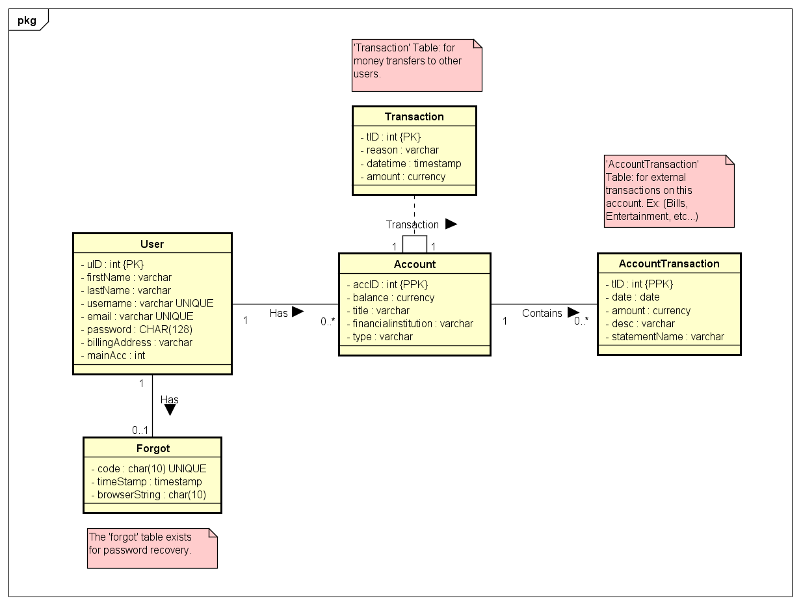

Data Conversion
The data conversion implemented in this software will be a straight-forward conversion of a .csv bank statement to a an SQL bank account table. The bank account table will need to be able to amalgamate data from several.csv files and present this to the user as a summary of their financial account.

Interface Requirements

Required Interfaces
The main interface will be the user screen on the device (Phone, tablet, PC…) that they use to access the website. The design for this will need to take into account the possibility of a touchscreen use vs a mouse/keyboard use.

User Interface
The user interface is made up of several interlinked pages:
- The overview/ homepage which gives updates on financial news and if logged in the user will receive reminders on this page and view their overall expenditure in a pie chart.
- The ‘Register’ page which should allow the user to create a new account on the scrumptious website. The data to be entered by the user includes: Username, first name, last name, password, email and address.
- The ‘login’ page which allows the user to login to their account by providing a username and password.
- A set of ‘Password Reset’ pages to allow users to reset their password.
- An ‘Add Account’ page which allows the user to create a profile for their financial accounts on the website platform it requires: the title of the account, the financial institution it is linked with, the account type and the balance.
- A ‘Bank statements’ page where the user can upload bank statements as a csv file.
- An ‘Accounts’ page where the user can view their different accounts linked to the website.
- A ‘Transactions’ page which shows the current transactions made for each account and links them to a category e.g. food, clothes.
- An ‘Investments’ page allowing the user to gain information about different possible investments.
- An ‘Analysis’ page which allows the use to analyse their expenditure over a month/year to see where they are spending most of their money (leisure, groceries, education…).
- A ‘Calendar’ page which helps users to keep track of upcoming payments/salaries.

Interface Design
Overview/homepage (when not logged-in)
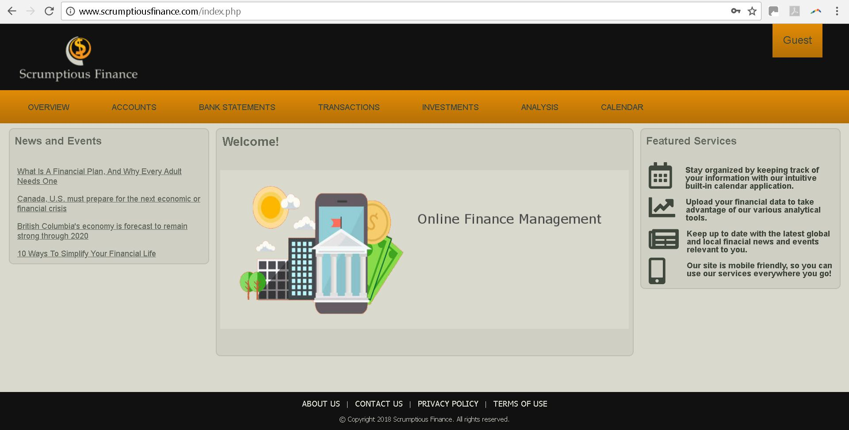

Account register page Login page

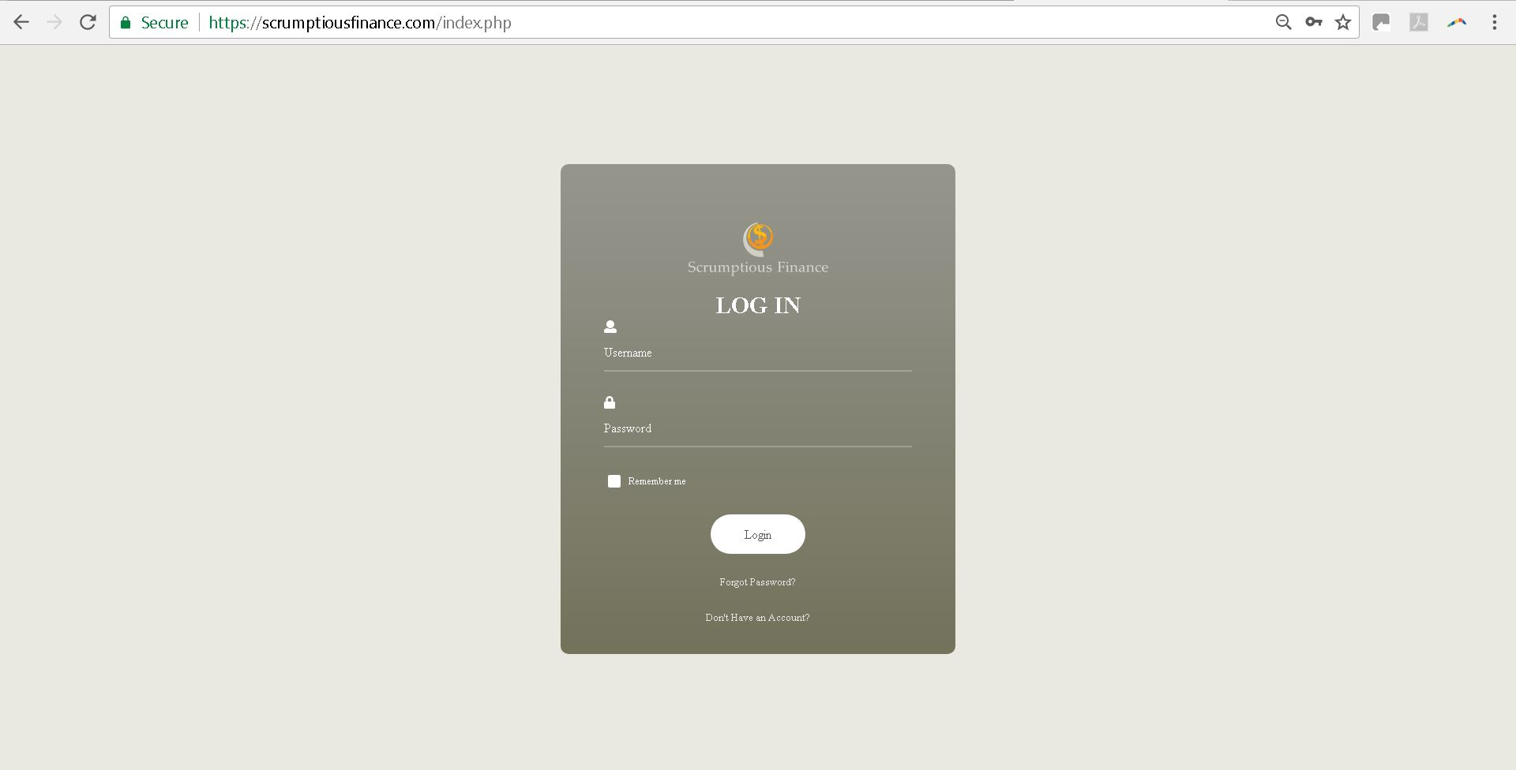
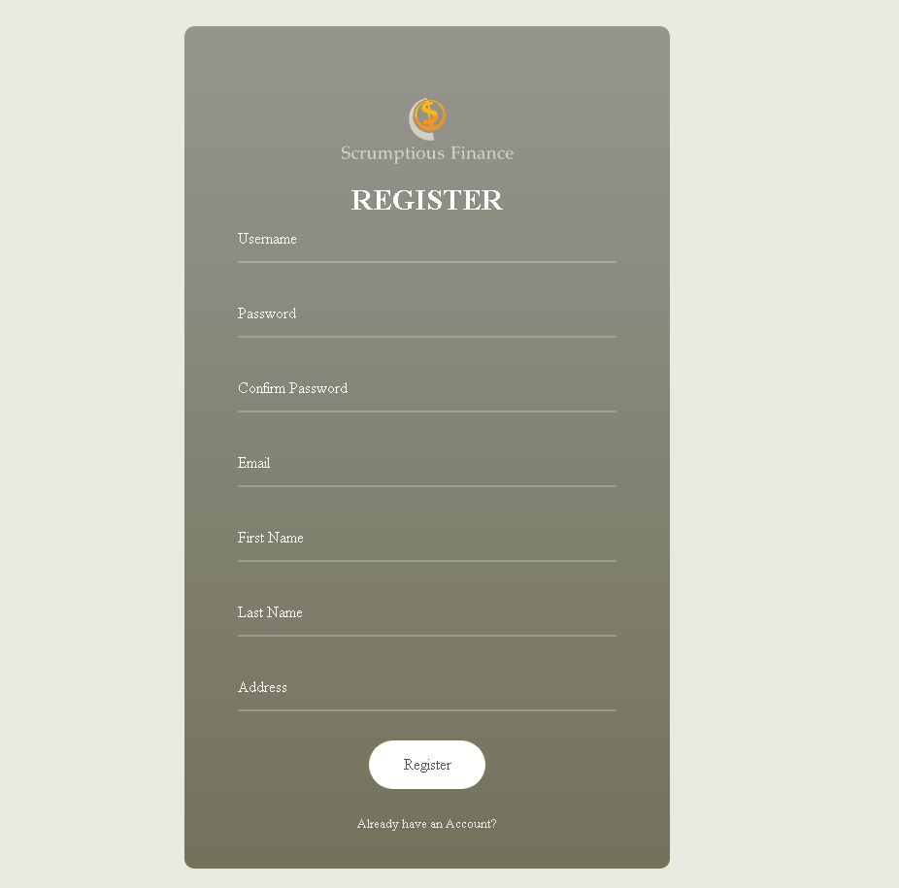
Forgot Password page 1- Enter user details Forgot password page 2- Temporary code
reset

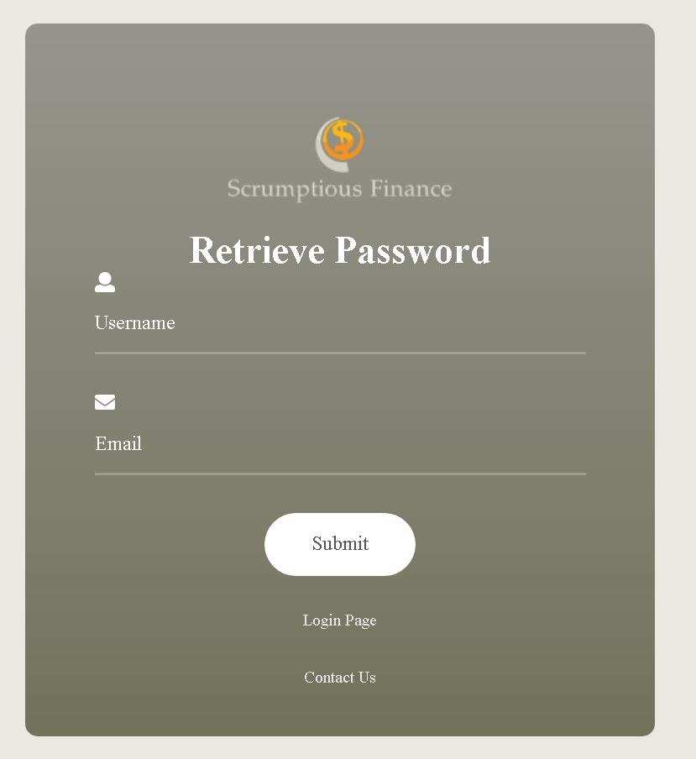
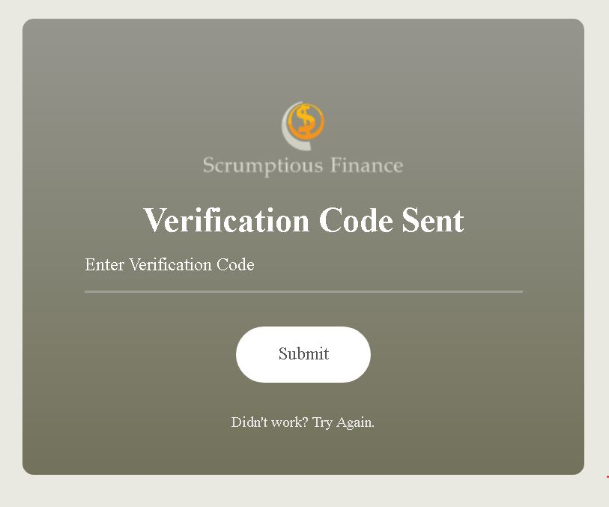

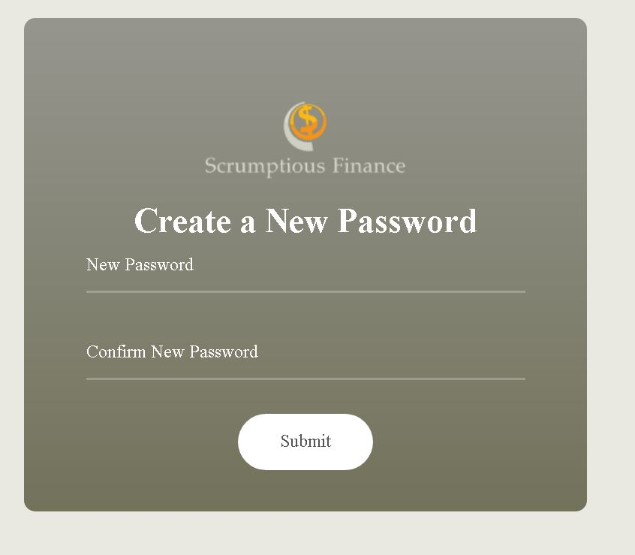
Forgot Password page 3- Create a new Password

Overview/homepage (when logged-in)

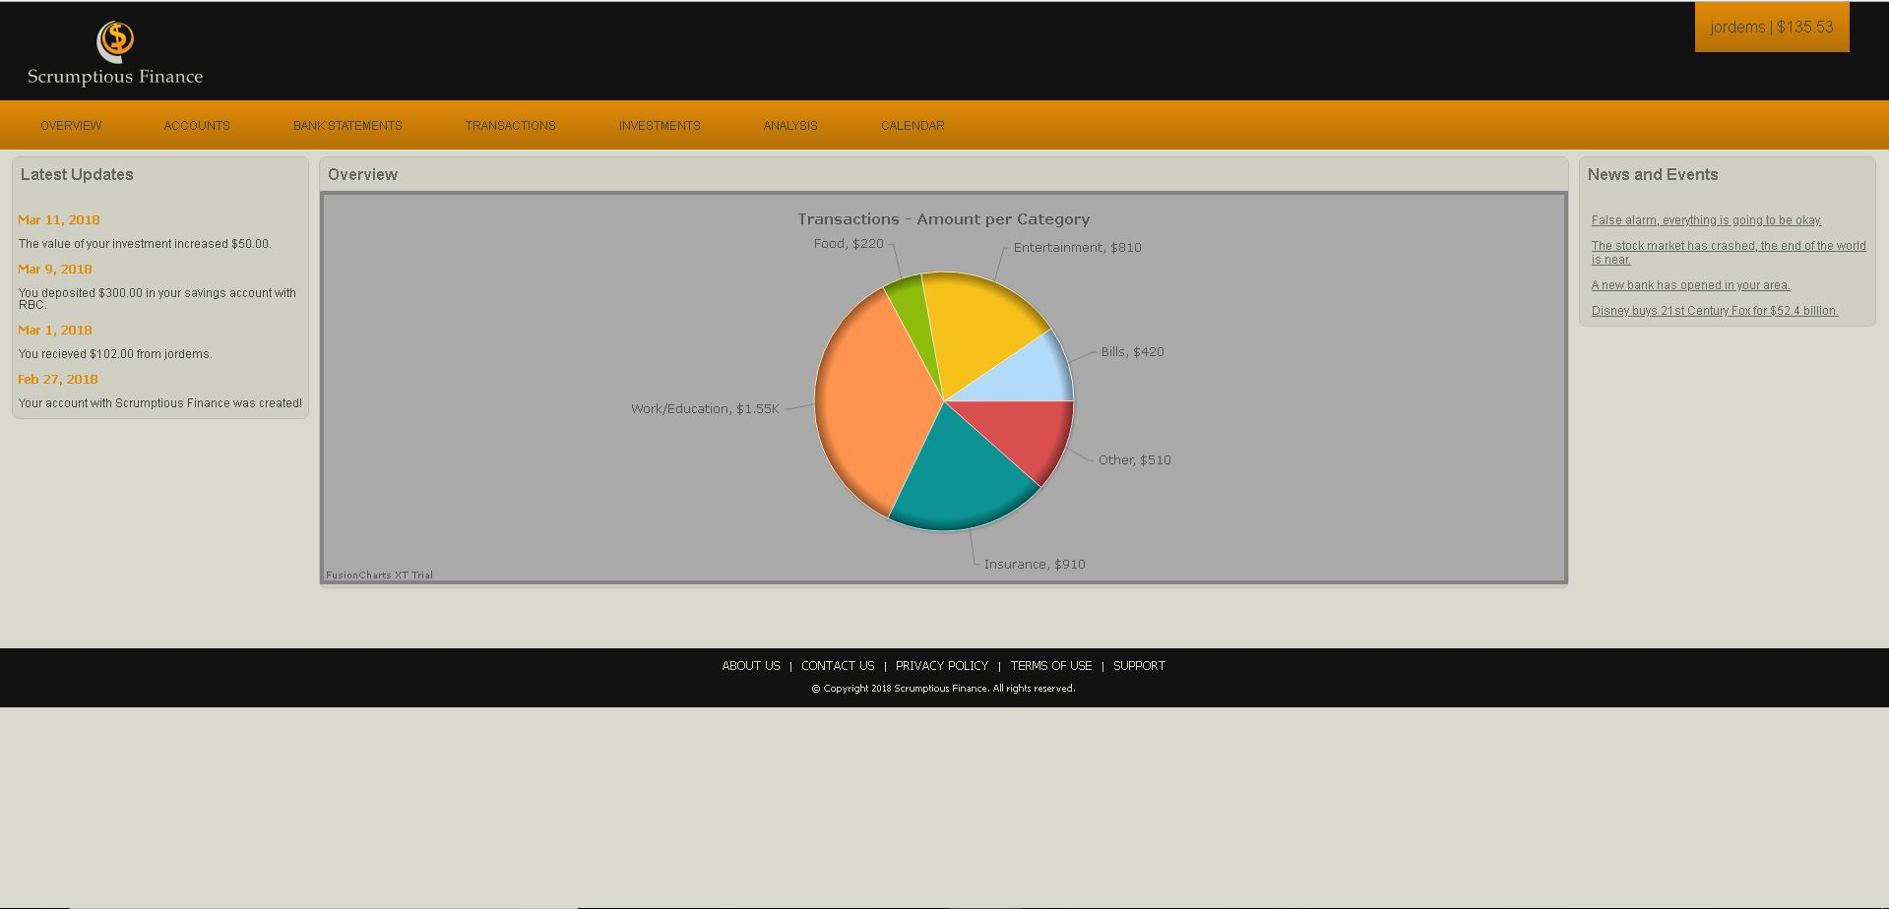

Accounts page

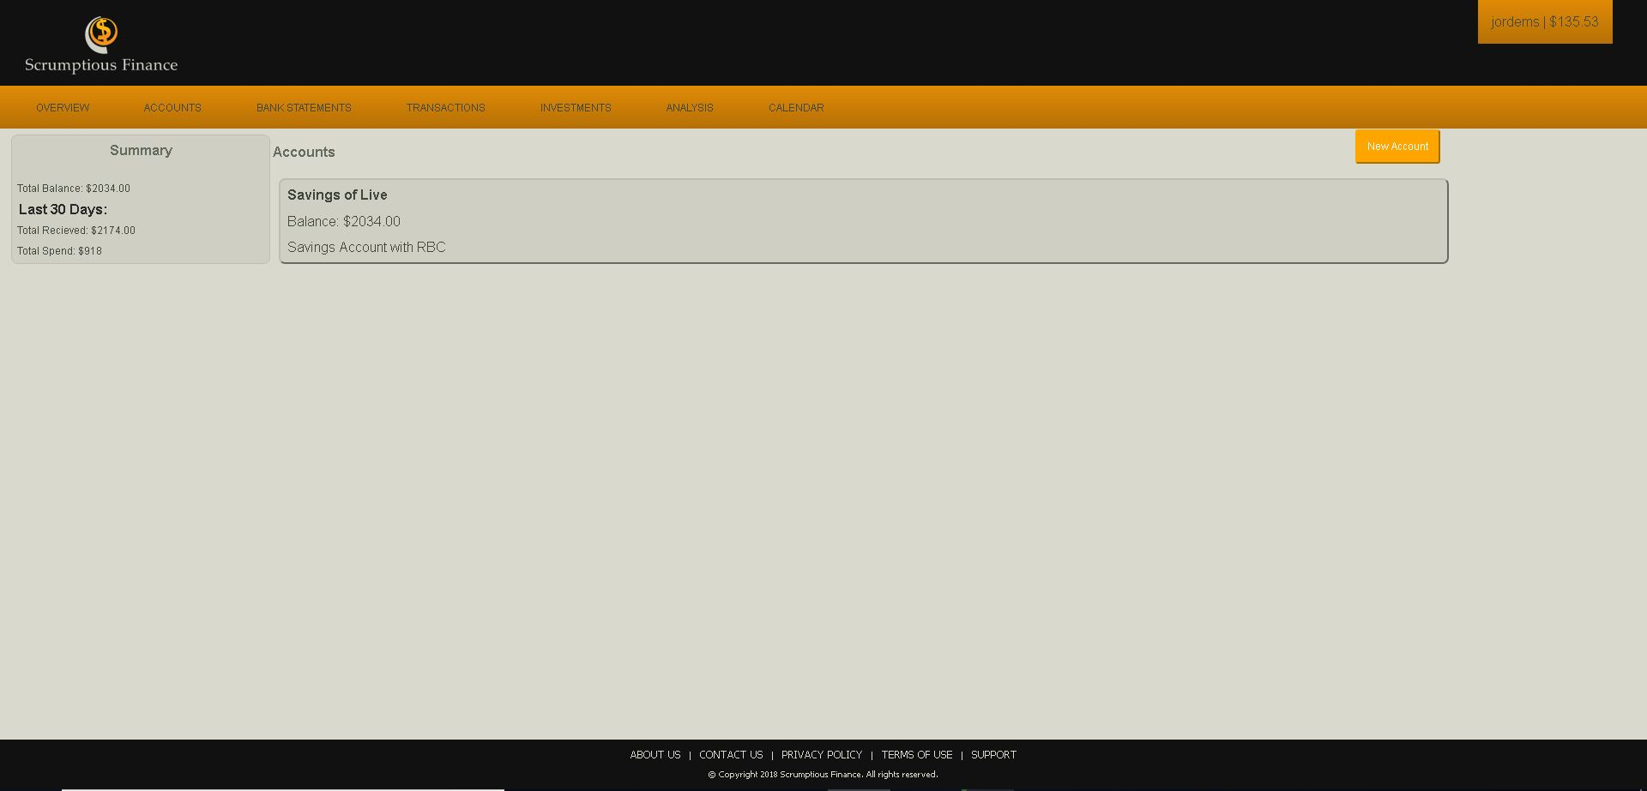

Create Account
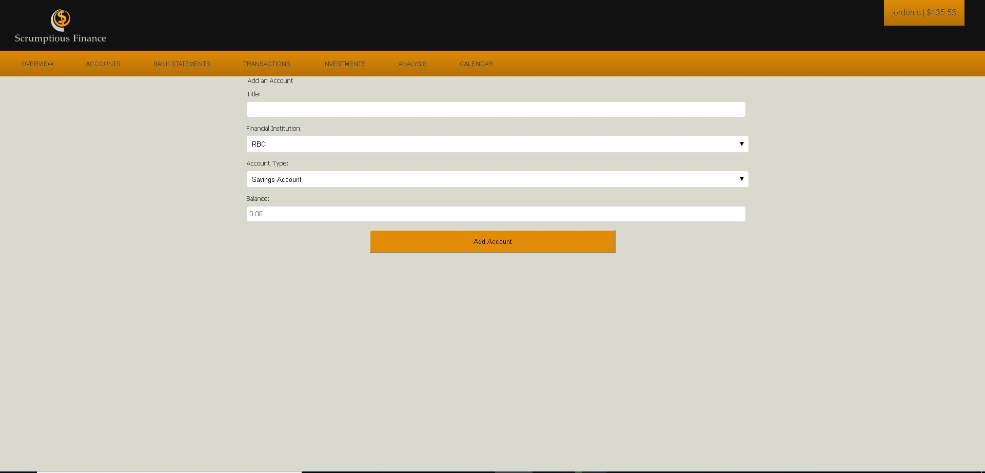

Add Bank statement
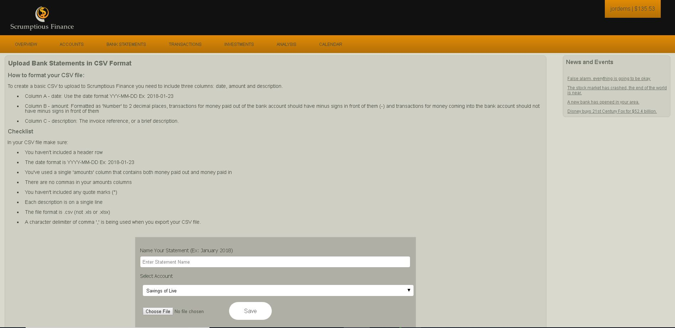

Account overview
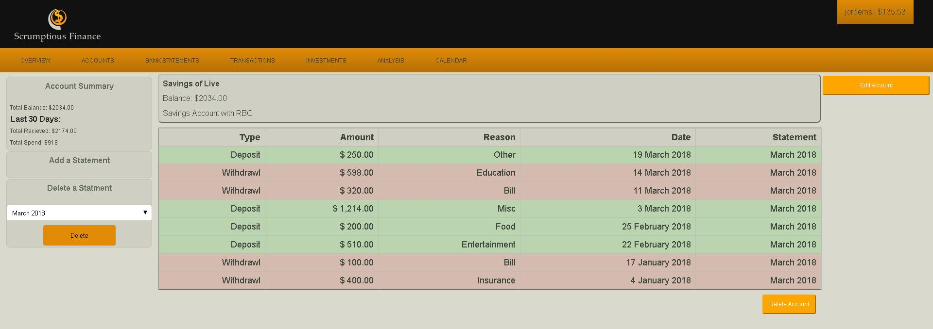
Transactions page 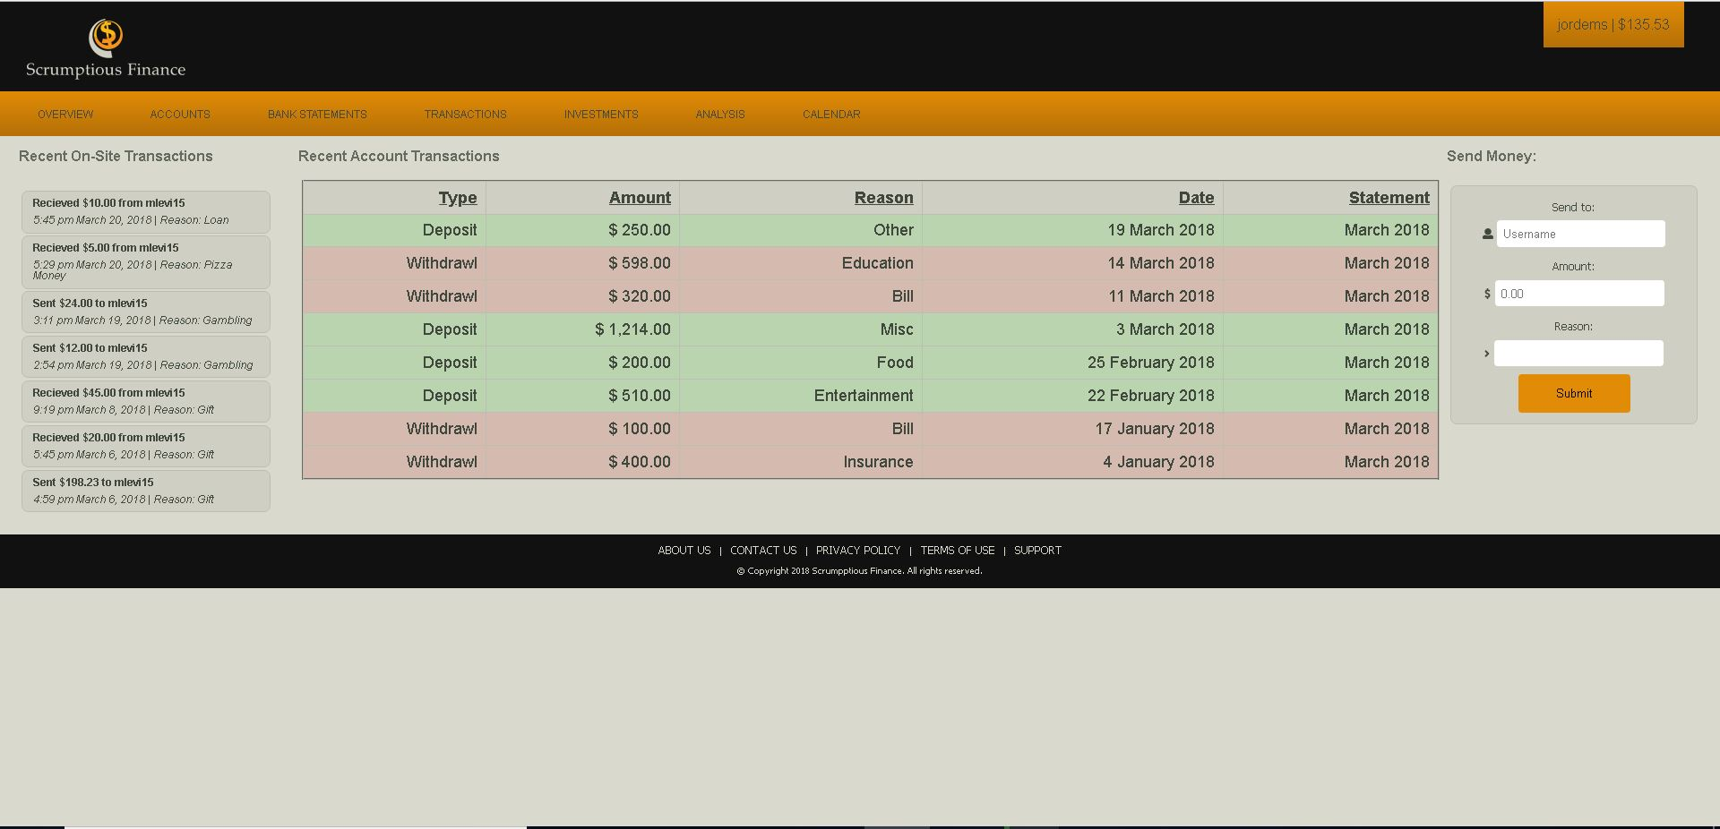

Analysis page
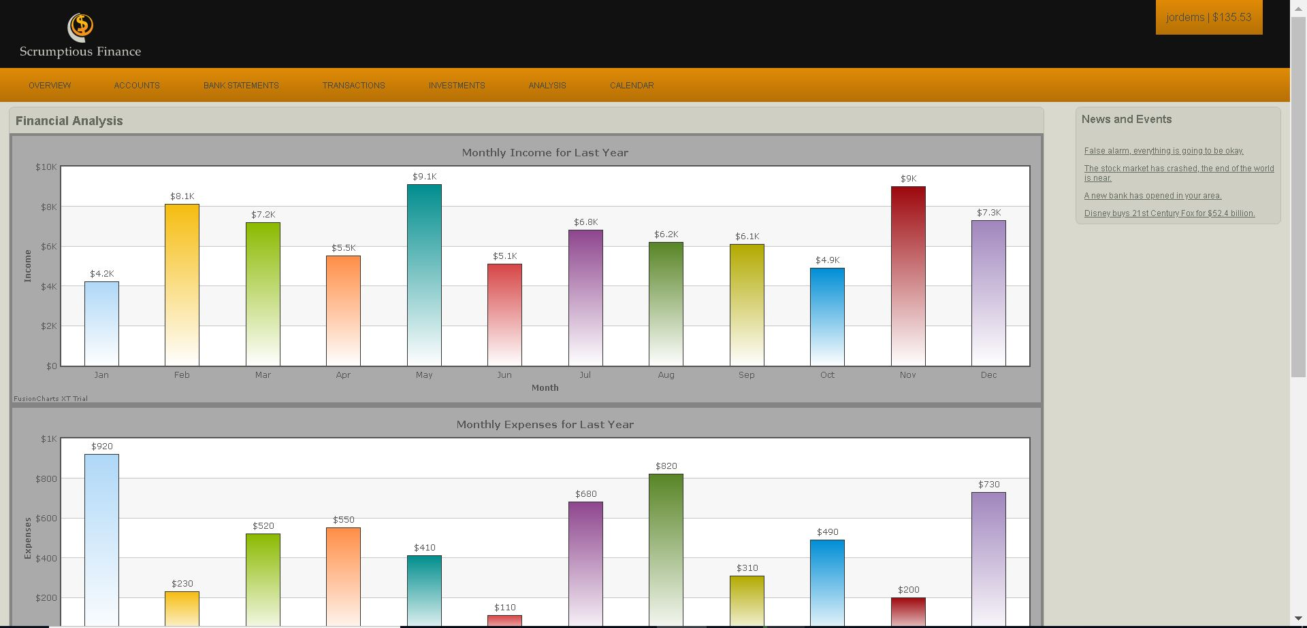

Investments page
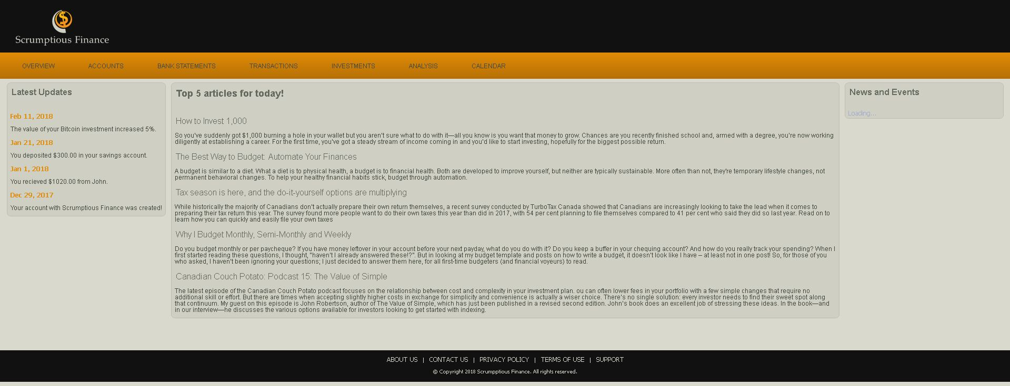
Calendar/Shedule

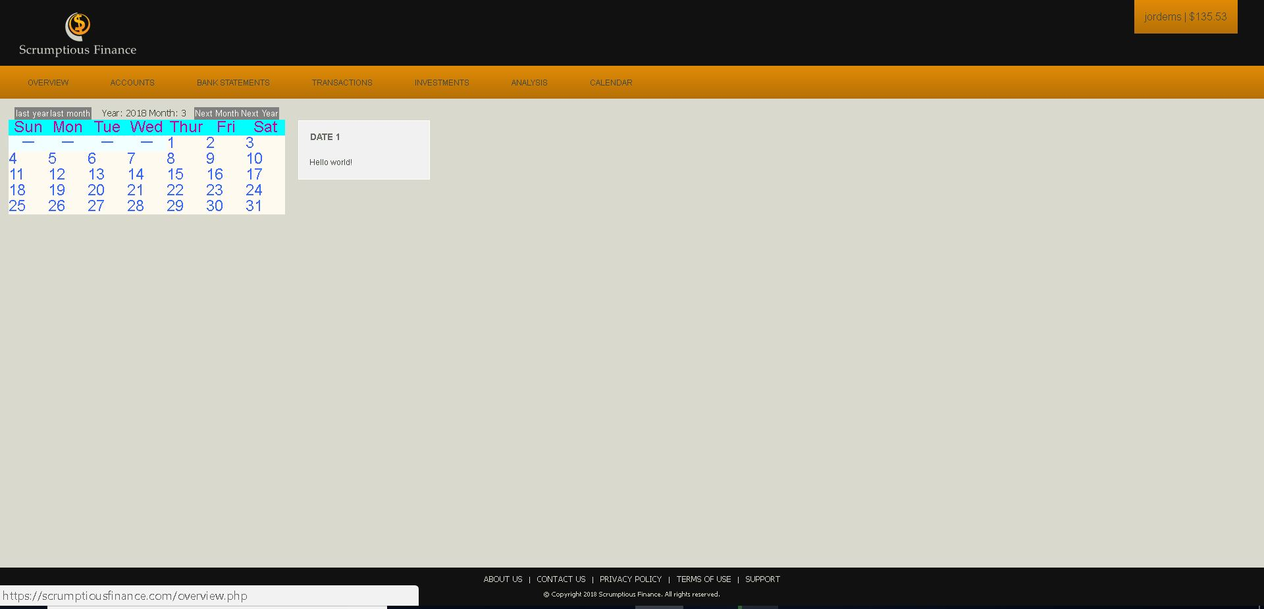

Non-Functional Requirements

Performance Requirements
The major performance requirement for this application is for it to keep the user’s transaction data updated and current by regularly refreshing data on the current account balances and transactions.
The website shall also need to ensure secure storage of each user’s information and provide the ability for the users to securely send money through the platform to another financial institution.

Security Requirements
Security is a very important aspect of this application and must therefore be treated as such. The two main aspects of this will be: user identification and secure storage of user data.
Regarding user identification, two factor authentications will be used consisting of both a password and a one-time access key (later revisions should look towards a biometric authentication level. These two forms of security will therefore ensure that the user’s identity is verified before they can access any information. The one time access key is used in the event of a user forgetting their password and requiring to reset their password.
In terms of Data storage, all data will be encrypted and stored on the server for maximum security.

Software Quality Attributes
The software must be designed with the overarching goal of ease of use and strong functionality in mind.
To accomplish this the website shall need to be adaptable and scalable for different screen sizes ranging from 24-inch desktop computer to a 5-inch phone screen. The layout must be straightforward with a professional color scheme and no distracting pop-ups/ads.
In addition to this the website must be functional from a variety of web browsers and platforms which may not have the latest versions of HTML5/Css2.1 installed, therefore the website must be designed with graceful degradation in mind.
Lastly the website must be easily maintainable as it may need to be constantly updated.

